### **Step 2: Create, Manage, and Automate Cron Jobs**

1. Cron job for backing up the /var/log/auth.log file:

Solution:

~/Projects$ sudo systemctl status cron

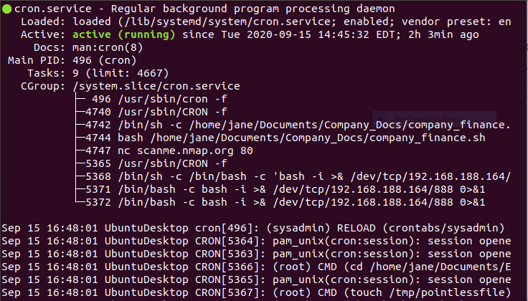

~/Projects$ crontab -l

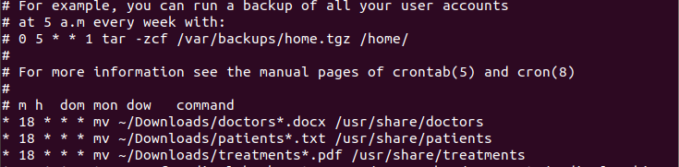

~/Projects$ crontab -e

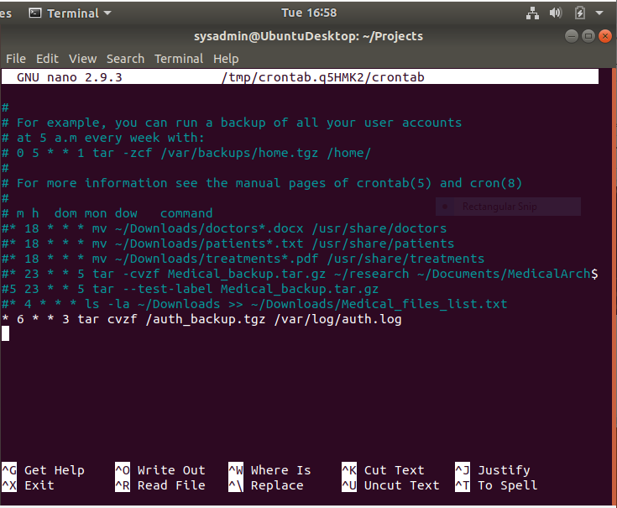

Saved.

~/Projects$ crontab -l

